%% Source Coding-HUFFMAN CODING AND DECODING %%
clc;
clear all;
close all;

n = input('Enter the number of symbol = ');
P = input('Enter their probabilitie =');
sig = 1:length(P);
symbols = 1:length(P);

%% Dictionary formation

[dict, avglen] = huffmandict(symbols, P);
temp = dict;
for i = 1: length(temp)
temp {i, 2} = num2str(temp{i, 2});
end
disp(temp);

%% Huffman encoder

X=input('enter the symbol');
Hcode = huffmanenco(X,dict);
Hcode
%% Huffman decoder

Decoder=huffmandeco(Hcode,dict);
Decoder
%% Computing entropy

h_x = 0;
for i = 1:length(P)
h_x = h_x - P(i)*log2(P(i));
end
h_x

%% Avg codeword length

L=avglen;
L

%% Efficiency

efficiency = h_x/avglen;
efficiency
%% Redundancy

redundancy=1-efficiency;
redundancy

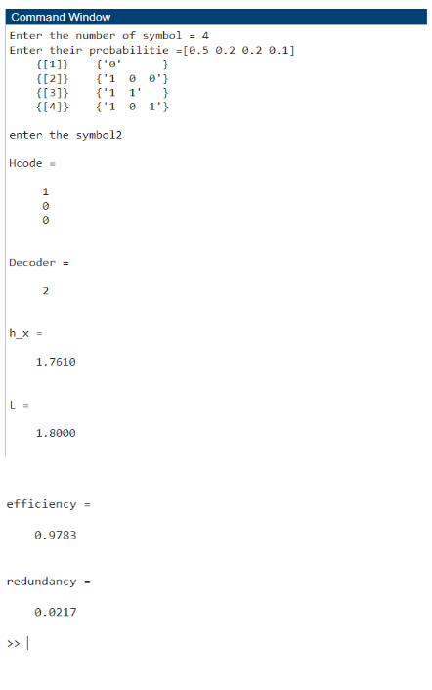
Enter the number of symbol = 4
Enter their probabilitie =[0.5 0.2 0.2 0.1]
{[1]} {'0' }
{[2]} {'1 0 0'}
{[3]} {'1 1' }
{[4]} {'1 0 1'}
enter the symbol2
Hcode =
1
0
0
Decoder =
2
h_x =
1.7610
L =
1.8000
efficiency =
0.9783
redundancy =
0.0217
>>

